4



**2**

**0**

**2**

**A Year In Review**

# 5,327

Total Outings

# $217,442

**1,224**

Total Unique Participants

North 1,239

Provided in Scholarships (Including scholarships for Veterans)

Central

# 453

Total Volunteers

# 80

Volunteers who dedicated 10+ days to our programs

**22**

Total Interns

# 75% Adults

**25% Kids**

The ratio of those who participate in our programs

1,232

South 1,408

Veterans 1,448

Annual Number of Year-Round Outings by Program Area

**Every Trail, Every Skill, EveryBODY.**

**Advancing Accessibility in**

* Vermont Adaptive conducted 21 water entryway assessments and 9 mountain bike trail network assessments throughout the state. These assessments allowed us to identify how to make these outdoor spaces accessible for all. The locations will now be reconfigured to ensure everyBODY has access to recreate.
* Volunteer training remains a critical piece to the success of the lessons and outings Vermont Adaptive provides. In 2024, we offered 63 trainings, both in-house and with sport-specific professionals for a total of 476 hours of training. This level of training will continue to increase in order to ensure we offer the safest and most current teaching techniques and education.
* Helping curate the next generation of adaptive sports programs is an integral part of Vermont Adaptive’s operations. Vermont Adaptive worked with 22 full- and part-time interns this past year including some who worked on their Capstone projects or graduate studies. Collectively, they contributed 7,270 hours to programs, lessons and more. Hands-on, in-the-field experience is important for these up and coming professionals.

**Disabilities of the People We Served In 2024**

## 24.18%

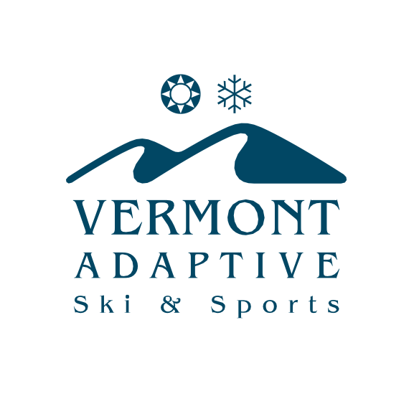

**Veterans (Miscellaneous Impairments)**

## 18.4%

**Cognitive/Intellectual Impairment**

## 18.02%

**Autism Spectrum Disorder**

## 8.79%

**Other PTSD/PTS/MST/Other Trauma**

## 7.55%

**Emotional Trauma/Emotional Behavioral Disability**

## 3.38%

**Blindness/Visual Impairment**

## 3.17%

**Parapalegia**

## 3.0%

**Veterans (No Impairment Identified)**

## 2.67%

**Cerebral Palsy**

## 1.13%

**Quadriplegia**

## 1.09%

**Traumatic Brain Injury**

## 0.94%

**Stroke**

## 0.58%

**Limb Amputations**

## 0.53%

**Spina Bifida**

## 0.54%

**Deaf or Hearing Impairment**

## 6.05%

**Other**

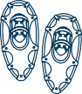[www.vermontadaptive.org](http://www.vermontadaptive.org/) • (802) 786-4991 •

